**Ansible modules**

. Ansible ships with number of modules (called library modules) that can be executed directly to remote hosts or playbooks.

. your library of modules can reside on any machine, and there are no servers, daemons or database required.

. the default location for the inventory file is /etc/Ansible/hosts

Step1:- ex1:-

.go to ansible server

. ansible dev[0] -b -m yum -a “pkg=git state=present”(m-module, b- root)

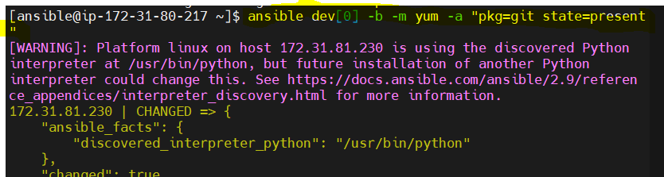

. go to node server

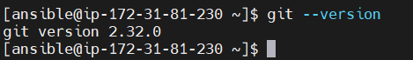

. How to remove installing package

. ansible dev[0] -b -m yum -a "pkg=git state=absent"



Ex:2:-

How to see users in linux



. Ansible is my last user

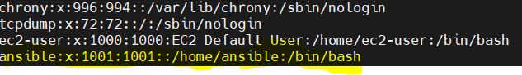

. iam adding one user in node server by using Ansible server

. some peoples are not mention in name properly, so they got error in below dia.

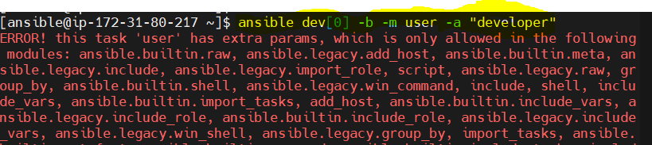

. so execute properly in command

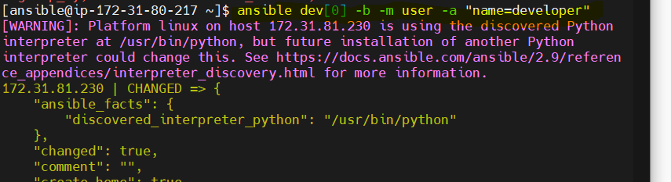

. go to node server search latest user

. cat /etc/passwd

. adding latest user

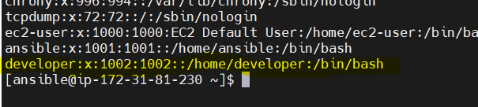

Ex:-3

. I am creating one file in ansible server

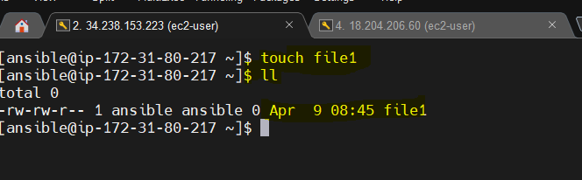

. how to copy file1 tonnode server

. ansible dev[0] -b -m copy -a “src=file1 dest=tmp”

. it will show node server destination folder

. cd /tmp/ . ls